**HTML | <embed> src Attribute**

Last Updated : 15 Jul, 2022

The **HTML <embed> src Attribute**is used to specify the web address of the embedded content.

**Syntax:**

<embed src="URL">

**Attribute Values:**

* **URL:**It is used to specify the web address of the embedded content.
  1. **An absolute URL:**It points to another webpage.
  2. **A relative URL:**it points to a file within a website.

**Example:**

**html**

|  |
| --- |
| <!DOCTYPE html>  <html>    <head>      <title>HTML embed src Attribute</title>      <style>          q {              color: #00cc00;              font-style: italic;          }      </style>  </head>    <body>      <h1>GeeksforGeeks</h1>      <h2>HTML embed src Attribute</h2>      <br>      <embed src="loading2.swf"             width="400px"             height="300px"             type="application/x-shockwave-flash">  </body>    </html> |

**Output :**

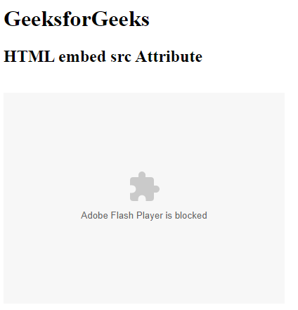

**Supported Browsers:**The browser supported by **HTML embed src Attribute** are listed below:

* Google Chrome 1 and above
* Edge 12 and above
* Internet Explorer 6 and above
* Firefox 1 and above
* Apple Safari 4 and above
* Opera 12.1 and above